HDMI (HDBaseT) Matrix Switcher Series
ITEM NO.: HE04M

With the latest and more affordable HDBaseT technology extend HDMI sources up to 100M at 1080p or 1920x1200. HE04M HDMI 4 by 4 Matrix Switcher allows for effortless control of up to 4 devices through IR remote control, RS-232 and the front panel.
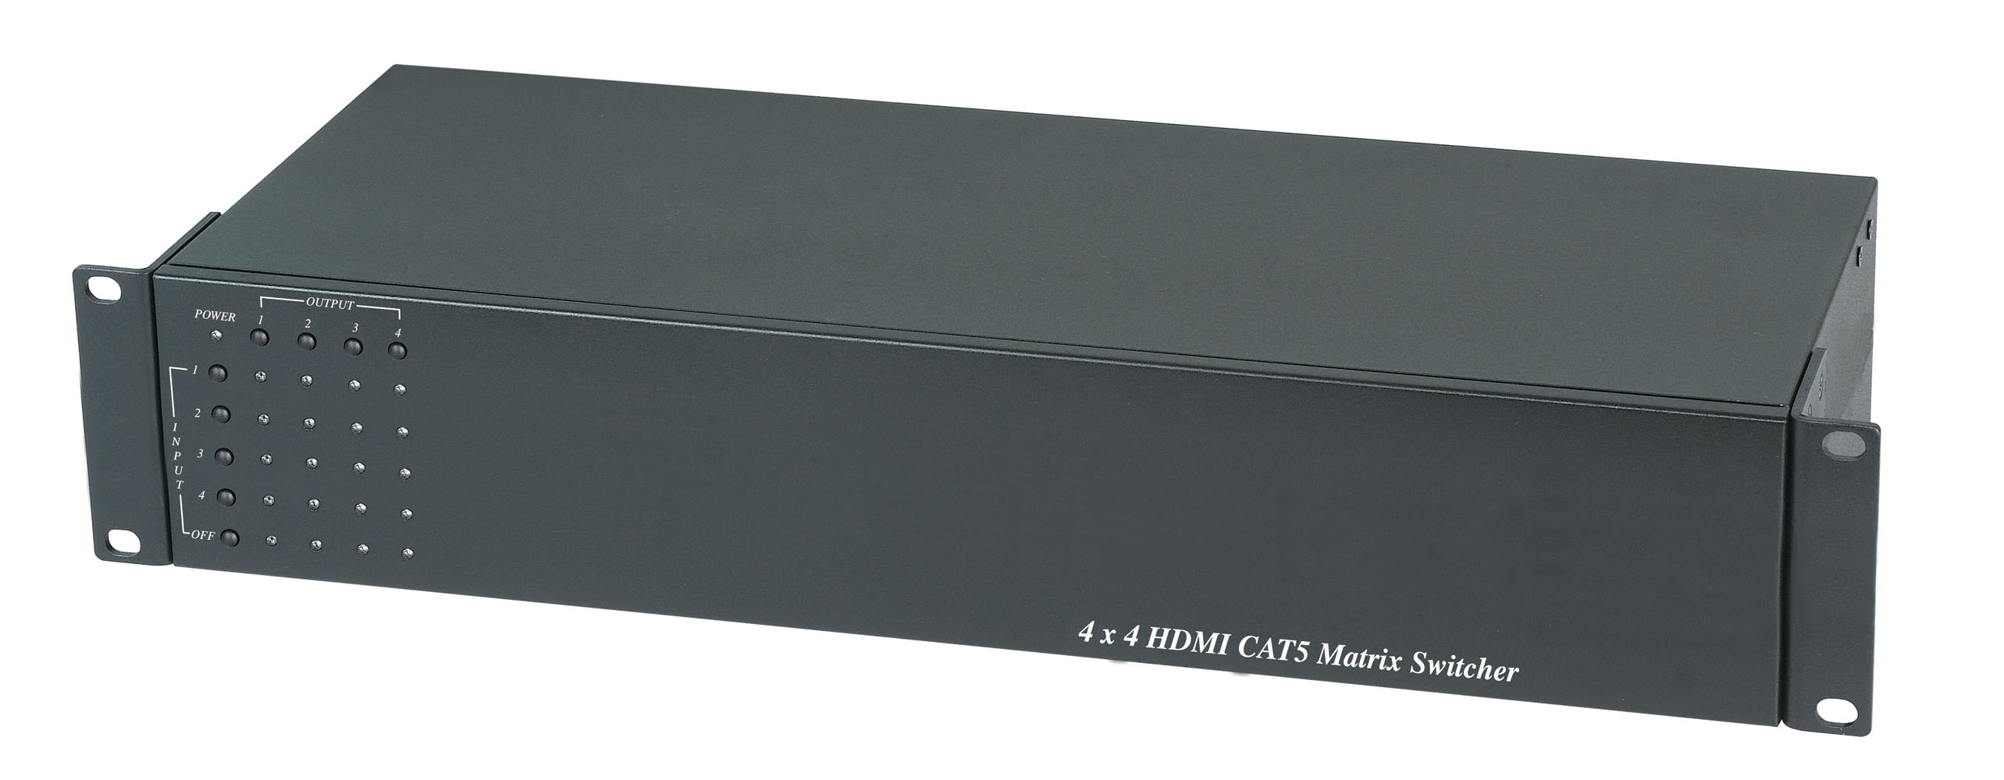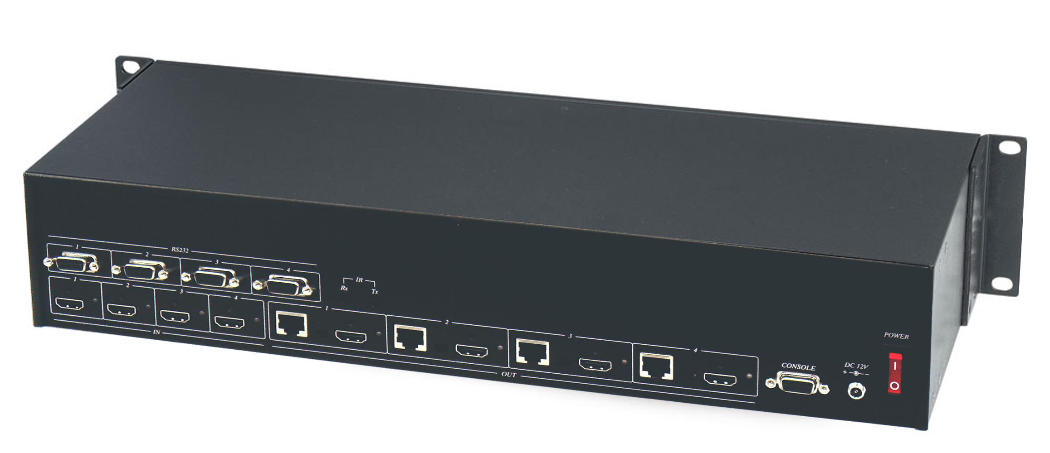

HE04M 4 x 4 HDMI (HDBaseT) Matrix Switcher
Feature:
- 4 x HDMI inputs , 4 x HDMI Outputs Matrix switcher
- Dual Output: local HDMI port or remote RJ45 termination
- Work with HE02ER, HE02R receiver at each monitor up to 100 meters over CAT5e/6.
- Work with HE02EIR receiver at each monitor up to 70 meters over CAT6a cable.
- Three control option: Front panel button, IR remote control, RS232 through remote PC.
- Support local/remote IR control to select input/output.
- Built in RS232 console port to select input/output.
- Uncompressed high definition video 1080p@60Hz 12 bit and 3D capable
- HDMI 1.4 video features supported.
- Built in IR extender (work with Receiver: HE02EIR)
- Built in RS232 extender ( work with Receiver: HE02R)
- Input/Output status could be displayed at panel LED.
- Optional Model:
HE02ER 100m HDMI Receiver
HE02R 100m HDMI & RS232 Receiver
HE02EIR 70m HDMI with IR Receiver

Panel View:

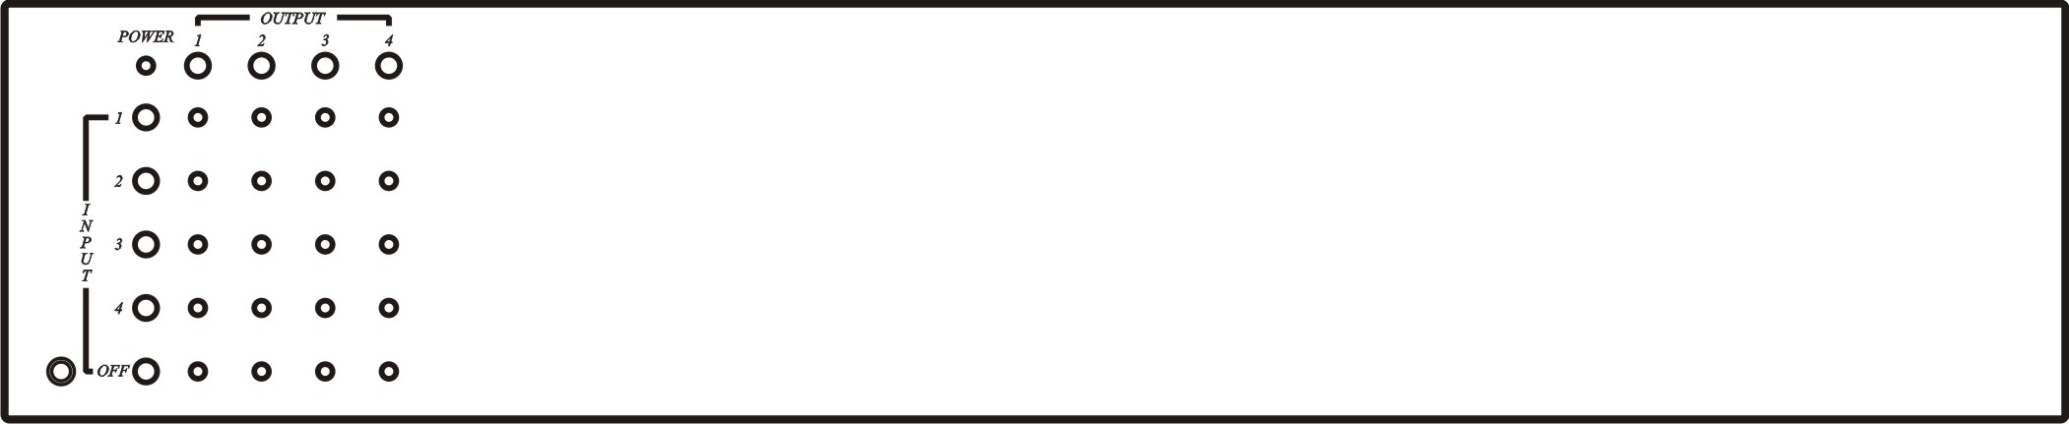

LED Indication:
Power ON/OFF

OUTPUT / INPUT: 1，2，3，4
1 2,3,4 LEDS Flash: Select INPUT Channel
LED ON : Input Selected

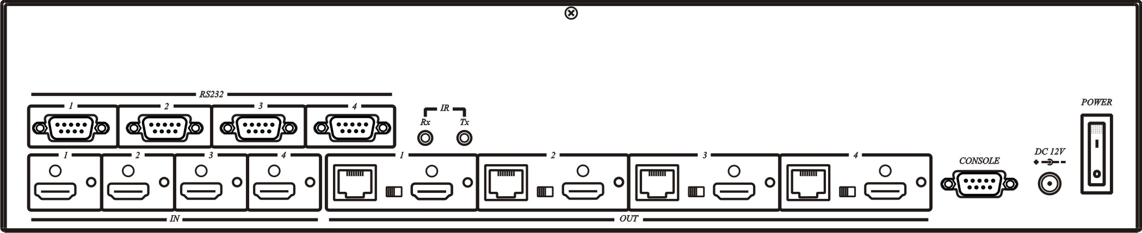
HDMI/RJ45 Output Selection:
Slide switch to right → HDMI OUT
Slide switch to left → Auto Detection HDMI or RJ45 output, HDMI priority when HDMI & RJ45 connection at the same time.

Input/Output Channel Switch:
- Select the output channel: press top button (1，2，3，4), the selected column will LEDS flash
- Select the input channel: press left button ( 1，2，3，4, OFF) to complete the channel selection.

Example 1 : Input 1 switch to output 2, to press top button 2, then press left button 1.
Example 2 : Turn off output 3 , to press top button 3 , then press left button OFF.

Local ( HE04M ) IR Control Function :
IR01 IR Remote Control Setting：
The ID number must be setup before using IR remote control or change new batteries.
Setup IR remote ID number: Press and hold “Power Symbol” button and press number 4.
Using IR01 remote controller to select input/output channel.

Input/Output Channel Switch:
- Select the output channel: press IR button (1，2，3，4) the selected column will LEDS flash
- Select the input channel: press IR button (7，8，9，＊, 0) to complete the channel selection.
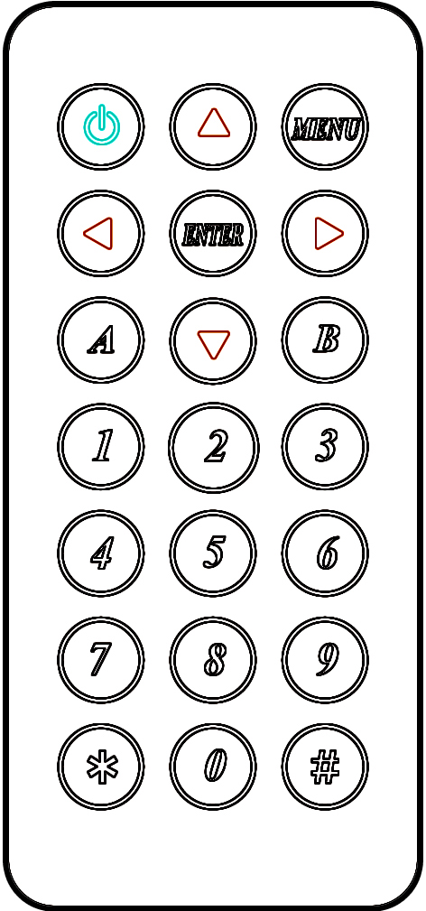
1 → Select Output 1
2 → Select Output 2
3 → Select Output 3
4 → Select Output 4
7 → Select Input 1
8 → Select Input 2
9 → Select Input 3
＊→ Select Input 4
0 → OFF

Remote IR Extender & HE04M Control Function :
IR01 IR Remote Control Setting：
The ID number must be setup before using IR remote control or change new batteries.
Setup IR remote ID number: Press and hold “Power Symbol”button and press number 5.

Work with HDMI source/monitor:
HE02EIR IR setting at TX, from local HE04M to control remote HDMI equipments.
HE02EIR IR setting at RX, from remote HDMI equipment to control local HE04M

Input/Output Channel Switch:
Select the input channel: press IR button (1，2，3，4, 0) the selected column will LEDS flash
1 → Select input 1
2 → Select input 2
3 → Select input 3
4 → Select input 4
0 → OFF
PC RS232 Port Remote Control (HE04M Console):
The communication format is 9600, 8, N, 1 (9600 bps, 1 start bit, 8 data bits, 1 stop bit).

Command List：
Use command as below：
Command + Space + Parameter + Enter

IN OUT
1. TX1 01 output 1 switch to input 1
2. TX1 02 output 1 switch to input 2
3. TX1 03 output 1 switch to input 3
4. TX1 04 output 1 switch to input 4
5. TX1 00 turn off output 1

6. TX2 01 output 2 switch to input 1
7. TX2 02 output 2 switch to input 2
8. TX2 03 output 2 switch to input 3
9. TX2 04 output 2 switch to input 4
10. TX2 00 turn off output 2

11. TX3 01 output 3 switch to input 1
12. TX3 02 output 3 switch to input 2
13. TX3 03 output 3 switch to input 3
14. TX3 04 output 3 switch to input 4
15. TX3 00 turn off output 3

16. TX4 01 output 4 switch to input 1
17. TX4 02 output 4 switch to input 2
18. TX4 03 output 4 switch to input 3
19. TX4 04 output 4 switch to input 4
20. TX4 00 turn off output 4

Installation View:
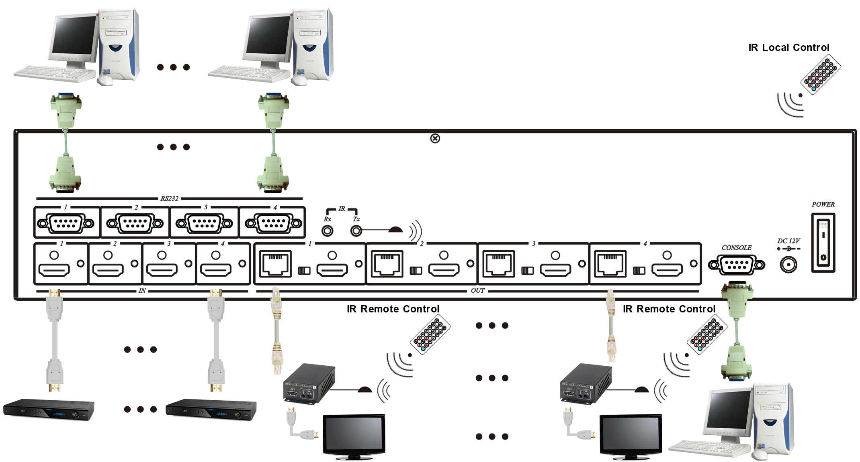

HE04MEK Package Include:
HE04M Matrix x 1 pcs
HE02ER HDMI Receiver x 4 pcs
IR01 IR Remote Control x 1 pcs
Power Adapter x 1 pcs

HE04MEIK Package Include:
HE04M Matrix x 1 pcs
HE02EIR HDMI Receiver x 4 pcs
IR01 IR Remote Control x 1 pcs
IR Emitter Cable x 4 pcs
IR Receiver Cable x 4 pcs
Power Adapter x 1 pcs

Specification:

Item No. | HE04M
Max. Resolution | 1080p @60Hz 12bit
Video Input | HDMI Type A x 4
Video Output | HDMI Type A x 4，RJ45 x4
RJ45 Output Distance | 100 meters
IR Input/Output | Phone Jack x 2
RS232 Input/Output | DB9 x 5
Power Adapter | DC 12V 4Amp
Power Consumption | 2Amp (Max)
Temperature | Operation: 0 to 55℃, Storage: -20 to 85℃, Humidity: up to 95%
Dimension mm | 483 × 220 × 88.4
Weight g | 3180

Item No. | HE02ER (Optional CAT5E Receiver) | HE02EIR (Optional CAT5E Receiver)
Resolution | Up to 1080p / 60Hz / 48 bit
Distance | 100M (Max) | 60M by CAT5e/6, 70M by CAT6a
Video Output | HDMI Type A x 1
IR Carrier Frequency | X | 30-60KHz
IR Angle | X | ±55
IR Distance | X | 5m
Power Supply | Regulated DC5V 2A
Power Consumption | 1200mA (Max) | 820mA (Max)
Temperature | Operation: 0 to 55℃, Storage: -20 TO 85℃, Humidity: up to 95%
Dimensions mm | 49 x 92.3 x 25
Weight g | 135 | 135

Rev. A

